2018 LADIES’ UNITED STATES OPEN CHAMPIONSHIP * BOSTON *

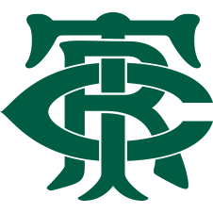

The TENNIS & RACQUET CLUB of Boston is very pleased to host:

2018 Ladies’ U.S. Open
United States Court Tennis Association Women’s Open Championship

TENNIS & RACQUET CLUB
Boston, Massachusetts
Friday, November 2nd – Sunday, November 4th

$100 Entry Fee

Women Tennis Players Of All Abilities Are Encouraged To Participate

Includes: Two guaranteed marked matches; commemorative gift; informal squash round-robin; USCTA Championship trophies; Saturday catered lunch; Saturday evening cocktail reception and Dutch treat dinner; and
general merriment.

Tournament Director:
Tony Hollins – Tony.Hollins@TandR.org
Tournament Chairs:
Magda and Matt Mitchell – mmitchell@psh.com

THE LADIES’ U.S. OPEN
Tennis & Racquet Club
Boston, Massachusetts
Friday, November 2nd – Sunday, November 4th

CHAMPIONSHIP ENTRY FORM

Entry Fee is $100

Name
Phone Number
Email
Dutch Treat Dinner | Yes / No | Squash Round Robin | Yes / No
Club Affiliation

Please return entry forms, via email, to Tony Hollins at Tony.Hollins@TandR.org

***

ENTRIES WILL CLOSE
Friday, October 19, 2018

