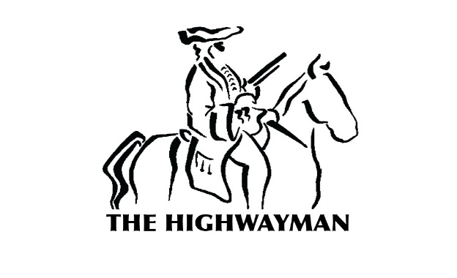
Saturday 3rd November 2018
£30.00 for 3 courses

A Red lentil, sweet potato and coconut soup

B Chicken and ham hock terrine with soused vegetables and croûtons

C Goat’s cheese, fig and pear tart with honey mustard dressing

D Highwayman smoked salmon roulade
with marinated citrus and pickled cucumber, horseradish cream

~~

E Grilled seabass with braised fennel, spinach, asparagus,
sautéed potatoes and dry sherry sauce

F Breaded cornfed chicken, courgette, asparagus, broccoli,
broad beans and mash potato

G Confit shoulder of mutton, Chantenay carrots,
garlic scented kale, colcannon

H Wild mushroom, chestnut and spinach Wellington
with winter vegetables, parmesan and garlic cream

~~

I Mulled winter fruits, spice bread and cinnamon ice cream

J Black forest artic roll
(white chocolate ice cream, chocolate sponge, marinated cherries)

K Buttermilk panna cotta, blood orange granita
and blood orange salad with orange shortbread

L Barkham blue, West country cheddar and oatcakes

All our dishes are cooked to order. Please be patient during busy periods.
Make us aware of any allergies and ask for further details of dishes that contain allergens.

